Computer Vision Programming Language: C++

Project #4 Morphology

Andres Quintero

Due Date:

Soft copy: 2/26/2020

Hard copy: 2/27/2020

Submission:

Soft copy: 2/26/2020

Hard copy: 2/27a/2020

*********************************************************************************************

Main():

Step 0: imgFile, structFile, dilateOutFile, erodeOutFile, openingOutFile, closingOutFile, prettyPrintFile 🡨 open

Step 1: numImgRows, numImgCols, imgMin, imgMax 🡨 read from imgFile

numStructRows, numStructCols, structMin, structMax 🡨 read from structFile

rowOrigin, colOrigin 🡨 read from strucFile

Step 2: zeroFramedAry, structAry, morphAry 🡨 dynamically allocate // see description in the above

Step 3: zero2DAry(zeroFramedAry) // see description in the above

Step 4: loadImg (imgFile, zeroFramedAry) // see description in the above

prettyPrint (zeroFramedAry, prettyPrintFile) // see description in the above

Step 5: zero2DAry(structAry)

loadstruct (structFile, structAry) // see description in the above

prettyPrint (structAry, prettyPrintFile) // see description in the above

Step 6: zero2DAry(morphAry)

ComputeDilation (…) // see algorithm below

AryToFile (morphAry, dilateOutFile) // see description in the above

prettyPrint (morphAry, prettyPrintFile)

Step 7: zero2DAry(morphAry)

ComputeErosion (…) // see algorithm below

AryToFile (morphAry, erodeOutFile)

prettyPrint (morphAry, prettyPrintFile)

Step 8: zero2DAry(morphAry)

ComputeOpening (…) // see algorithm below

AryToFile (morphAry, openingOutFile)

prettyPrint (morphAry, prettyPrintFile)

Step 9: zero2DAry(morphAry)

ComputeClosing (…) // see algorithm below

AryToFile (morphAry, closingOutFile)

prettyPrint (morphAry, prettyPrintFile)

Step 10: close all files

**Sorce Code:**

#include <iostream>

#include <fstream>

#include <string>

using namespace std;

//DEBUGSTUFF

void printArrayDebug(int** array, int rows, int cols){

for(int i = 0; i < rows; i++){

for(int j = 0; j < cols; j++){

cout << array[i][j] << " ";

}

cout << endl;

}

}

// Prototypes

void zero2DAry(int** array, int rows, int cols);

void loadImage(fstream& imgFile, int** zeroFrameAry, int rows, int cols);

void loadImage(fstream& imgFile, int** zeroFrameAry, int row, int col, int rowFrameSize, int colFrameSize);

void prettyPrint(int** array, fstream& outFile, int rows, int cols);

void loadStruct(fstream& structFile, int** structAry, int rows, int cols);

void ComputeDilation(int** zeroFrameAry, int** morphAry, int rowFrameSize, int colFrameSize, int numStructRows, int numStructCols, int rowOrigin, int colOrigin);

void dilation(int i, int j, int** morphAry, int rowOrigin, int colOrigin);

void ComputeErosion(int** zeroFrameAry, int** morphAry, int** structAry, int rowFrameSize, int colFrameSize, int numImgRows, int numImgCols, int numStructRows,int numStructCols, int rowOrigin, int colOrigin);

void erosion(int i, int j, int** morphAry, int** structAry, int** zeroFrameAry, int rowOrigin, int colOrigin);

void AryToFile(int** array, fstream& outFile, int rows, int cols, int extraRows, int extraCols, int min, int max);

void ComputeOpening(int** zeroFrameAry, int** morphAry, int** structAry, int rowFrameSize, int colFrameSize, int numImgRows, int numImgCols,int numStructRows,int numStructCols, int rowOrigin, int colOrigin, int extraRows, int extraCols);

void ComputeClosing(int** zeroFrameAry, int** morphAry, int** structAry, int rowFrameSize, int colFrameSize, int numImgRows, int numImgCols,int numStructRows,int numStructCols, int rowOrigin, int colOrigin, int extraRows, int extraCols);

int main(int argc, char* argv[]) {

fstream imgFile(argv[1]); // Image

fstream structFile(argv[2]); // Structuring element

fstream dilateOutFile(argv[3], fstream::out);

fstream erodeOutFile(argv[4], fstream::out);

fstream openingOutFile(argv[5], fstream::out);

fstream closingOutFile(argv[6], fstream::out);

fstream prettyPrintFile(argv[7], fstream::out);

// Varibles

int numImgRows, numImgCols, imgMin, imgMax;

int numStructRows, numStructCols, structMin, structMax, rowOrigin, colOrigin;

// Reading from imgFile

imgFile >> numImgRows;

imgFile >> numImgCols;

imgFile >> imgMin;

imgFile >> imgMax;

// Reading from structFile

structFile >> numStructRows;

structFile >> numStructCols;

structFile >> structMin;

structFile >> structMax;

structFile >> rowOrigin;

structFile >> colOrigin;

// Initiazing array variables

int rowFrameSize = numStructRows/2, colFrameSize = numStructCols/2;

int extraRows = rowFrameSize*2, extraCols = colFrameSize*2;

int **zeroFrameAry = new int*[numImgRows+extraRows];

for(int i = 0; i < numImgRows+extraRows; i++){

zeroFrameAry[i] = new int[numImgCols+extraCols];

}

int **morphAry = new int*[numImgRows+extraRows];

for(int i = 0; i < numImgRows+extraRows; i++){

morphAry[i] = new int[numImgCols+extraCols];

}

int **structAry = new int*[numStructRows];

for(int i = 0; i < numStructRows; i++){

structAry[i] = new int[numStructCols];

}

// Loading Image

zero2DAry(zeroFrameAry, numImgRows+extraRows, numImgCols+extraCols);

loadImage(imgFile, zeroFrameAry, numImgRows+extraRows, numImgCols+extraCols, rowFrameSize, colFrameSize);

prettyPrint(zeroFrameAry, prettyPrintFile, numImgRows+extraRows, numImgCols+extraCols);

// Loading Structuring Element

zero2DAry(structAry, numStructRows, numStructCols);

loadStruct(structFile, structAry, numStructRows, numStructCols);

prettyPrint(structAry, prettyPrintFile, numStructRows, numStructCols);

// Dilation

zero2DAry(morphAry, numImgRows+extraRows, numImgCols+extraCols);

ComputeDilation(zeroFrameAry, morphAry, rowFrameSize, colFrameSize, numImgRows, numImgCols, rowOrigin, colOrigin);

AryToFile(morphAry, dilateOutFile, numImgRows, numImgCols, extraRows, extraCols, imgMin, imgMax);

prettyPrint(morphAry, prettyPrintFile, numImgRows+extraRows, numImgCols+extraCols);

// Erosion

zero2DAry(morphAry, numImgRows+extraRows, numImgCols+extraCols);

ComputeErosion(zeroFrameAry, morphAry, structAry, rowFrameSize, colFrameSize, numImgRows, numImgCols, numStructRows, numStructCols, rowOrigin, colOrigin);

AryToFile(morphAry, erodeOutFile, numImgRows, numImgCols, extraRows, extraCols, imgMin, imgMax);

prettyPrint(morphAry, prettyPrintFile, numImgRows+extraRows, numImgCols+extraCols);

// Opening

zero2DAry(morphAry, numImgRows+extraRows, numImgCols+extraCols);

ComputeOpening(zeroFrameAry, morphAry, structAry, rowFrameSize, colFrameSize, numImgRows, numImgCols, numStructRows, numStructCols, rowOrigin, colOrigin, extraRows, extraCols);

AryToFile(morphAry, openingOutFile, numImgRows, numImgCols, extraRows, extraCols, imgMin, imgMax);

prettyPrint(morphAry, prettyPrintFile, numImgRows+extraRows, numImgCols+extraCols);

// Closing

zero2DAry(morphAry, numImgRows+extraRows, numImgCols+extraCols);

ComputeClosing(zeroFrameAry, morphAry, structAry, rowFrameSize, colFrameSize, numImgRows, numImgCols, numStructRows, numStructCols, rowOrigin, colOrigin, extraRows, extraCols);

AryToFile(morphAry, closingOutFile, numImgRows, numImgCols, extraRows, extraCols, imgMin, imgMax);

prettyPrint(morphAry, prettyPrintFile, numImgRows+extraRows, numImgCols+extraCols);

//Closing all files

imgFile.close();

structFile.close();

dilateOutFile.close();

erodeOutFile.close();

openingOutFile.close();

closingOutFile.close();

prettyPrintFile.close();

}

void ComputeClosing(int** zeroFrameAry, int** morphAry, int** structAry, int rowFrameSize, int colFrameSize, int numImgRows, int numImgCols,int numStructRows,int numStructCols, int rowOrigin, int colOrigin, int extraRows, int extraCols){

// Dilation then Erosion

//creating a tempArray

int **tempArray = new int*[numImgRows+extraRows];

for(int i = 0; i < numImgRows+extraRows; i++){

tempArray[i] = new int[numImgCols+extraCols];

}

zero2DAry(tempArray, numImgRows+extraRows, numImgCols+extraCols);

ComputeDilation(zeroFrameAry, morphAry, rowFrameSize, colFrameSize, numImgRows, numImgCols, rowOrigin, colOrigin);

ComputeErosion(morphAry, tempArray, structAry, rowFrameSize, colFrameSize, numImgRows, numImgCols, numStructRows, numStructCols, rowOrigin, colOrigin);

// Copy tempArray back to morphAry

for(int i = 0; i < numImgRows+extraRows; i++){

for(int j = 0; j < numImgCols+extraCols; j++){

morphAry[i][j] = tempArray[i][j];

}

}

// deallocate tempArray

for(int i = 0; i < numImgCols+extraCols; i++) { delete[] tempArray[i];}

delete[] tempArray;

}

void ComputeOpening(int** zeroFrameAry, int** morphAry, int** structAry, int rowFrameSize, int colFrameSize, int numImgRows, int numImgCols,int numStructRows,int numStructCols, int rowOrigin, int colOrigin, int extraRows, int extraCols){

// Erosion then Dilation

//creating a tempArray

int **tempArray = new int*[numImgRows+extraRows];

for(int i = 0; i < numImgRows+extraRows; i++){

tempArray[i] = new int[numImgCols+extraCols];

}

zero2DAry(tempArray, numImgRows+extraRows, numImgCols+extraCols);

ComputeErosion(zeroFrameAry, morphAry, structAry, rowFrameSize, colFrameSize, numImgRows, numImgCols, numStructRows, numStructCols, rowOrigin, colOrigin);

ComputeDilation(morphAry, tempArray, rowFrameSize, colFrameSize, numImgRows, numImgCols, rowOrigin, colOrigin);

// Copy tempArray back to morphAry

for(int i = 0; i < numImgRows+extraRows; i++){

for(int j = 0; j < numImgCols+extraCols; j++){

morphAry[i][j] = tempArray[i][j];

}

}

// deallocate tempArray

for(int i = 0; i < numImgCols+extraCols; i++) { delete[] tempArray[i];}

delete[] tempArray;

}

// Functions

void AryToFile(int** array, fstream& outFile, int rows, int cols, int extraRows, int extraCols, int min, int max){

outFile << rows << " " << cols << " " << min << " " << max << endl;

int rowPadding = extraRows/2;

int colPadding = extraCols/2;

for(int i = rowPadding; i < rows+rowPadding; i++){

for(int j = colPadding; j < cols+colPadding; j++){

if(array[i][j] == 0){

outFile << "0 ";

} else {

outFile << array[i][j] << " ";

}

}

outFile << endl;

}

}

void erosion(int i, int j, int** morphAry, int** structAry, int** zeroFrameAry, int numStructRows, int numStructCols, int rowOrigin, int colOrigin){

bool match = true;

int rOffset = i - rowOrigin;

int cOffset = j - colOrigin;

int r , c;

r = 0;

while(r < numStructRows && match){

c = 0;

while (c < numStructCols && match){

if(structAry[r][c] > 0 && zeroFrameAry[rOffset+r][cOffset+c] == 0) { match = false;}

c++;

}

r++;

}

if(match){ morphAry[i][j] = 1;}

}

void dilation(int i, int j, int** morphAry, int rowOrigin, int colOrigin){

for(int a = 0; a < rowOrigin+1; a++){

for(int b = 0; b < colOrigin+1; b++){

morphAry[i-a][j-b] = 1;

}

}

for(int a = 0; a < rowOrigin+1; a++){

for(int b = 0; b < colOrigin+1; b++){

morphAry[i+a][j+b] = 1;

}

}

}

void ComputeErosion(int** zeroFrameAry, int** morphAry, int** structAry, int rowFrameSize, int colFrameSize, int numImgRows, int numImgCols,int numStructRows,int numStructCols, int rowOrigin, int colOrigin){

int i, j;

i = rowFrameSize;

while(i<numImgRows+rowFrameSize){

j = colFrameSize;

while(j<numImgCols+colFrameSize){

if(zeroFrameAry[i][j] > 0) {erosion(i, j, morphAry, structAry, zeroFrameAry, numStructRows, numStructCols, rowOrigin, colOrigin);}

j++;

}

i++;

}

}

void ComputeDilation(int** zeroFrameAry, int** morphAry, int rowFrameSize, int colFrameSize, int numImgRows, int numImgCols, int rowOrigin, int colOrigin){

int i, j;

i = rowFrameSize;

while(i<numImgRows+rowFrameSize){

j = colFrameSize;

while(j<numImgCols+colFrameSize){

if(zeroFrameAry[i][j] > 0) {dilation(i, j, morphAry, rowOrigin, colOrigin);}

j++;

}

i++;

}

}

void loadStruct(fstream& structFile, int** structAry, int rows, int cols){

int value;

for(int i = 0; i < rows; i++){

for(int j = 0; j < cols; j++){

structFile >> value;

structAry[i][j] = value;

}

}

}

void prettyPrint(int** array, fstream& outFile, int rows, int cols){

for(int i = 0; i < rows; i++){

for(int j = 0; j < cols; j++){

if(array[i][j] == 0){

outFile << ". ";

} else {

outFile << array[i][j] << " ";

}

}

outFile << endl;

}

outFile << endl;

}

void loadImage(fstream& imgFile, int** zeroFrameAry, int rows, int cols, int rowFrameSize, int colFrameSize){

int value;

for(int i = rowFrameSize; i < rows-rowFrameSize; i++){

for(int j = colFrameSize; j < cols-colFrameSize; j++){

imgFile >> value;

zeroFrameAry[i][j] = value;

}

}

}

void zero2DAry(int** array, int rows, int cols){

for(int i = 0; i < rows; i++){

for(int j = 0; j < cols; j++){

array[i][j] = 0;

}

}

}

**TEST 1: Img-1, Struct-3**

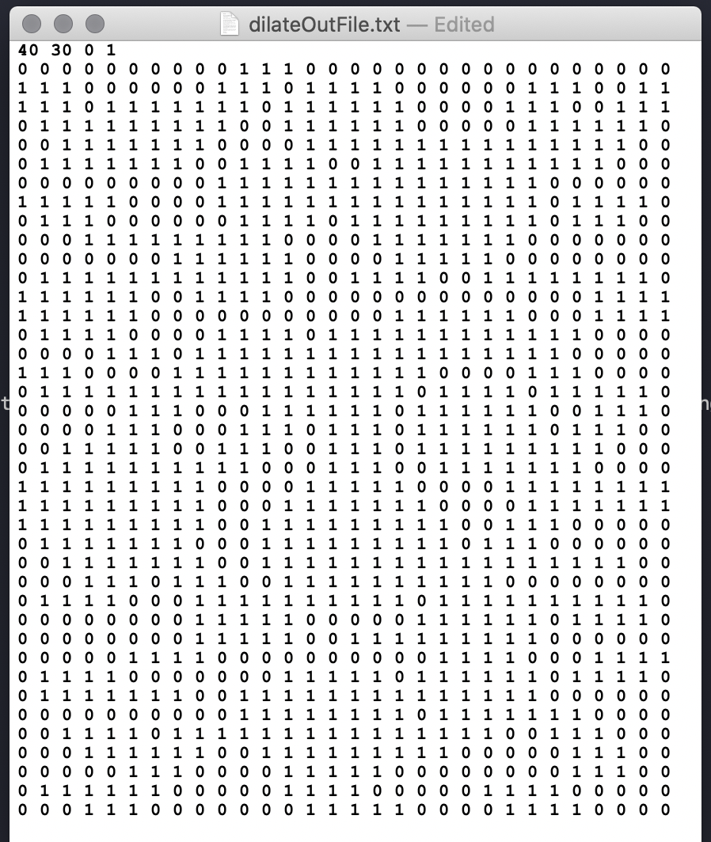

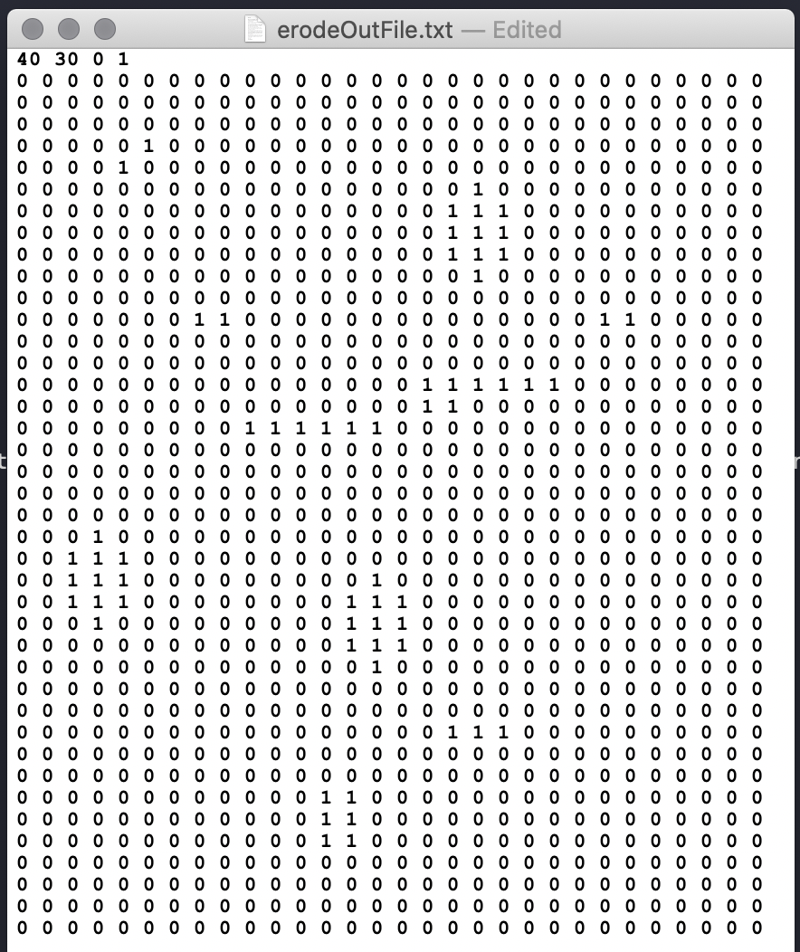

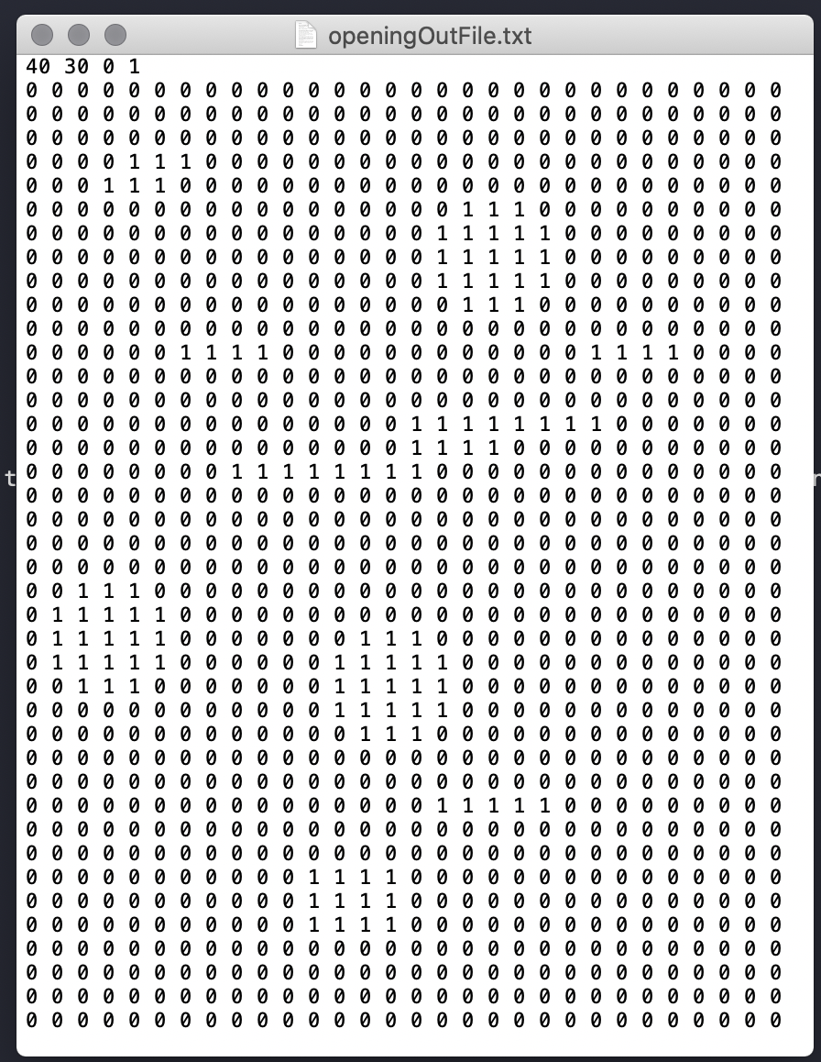

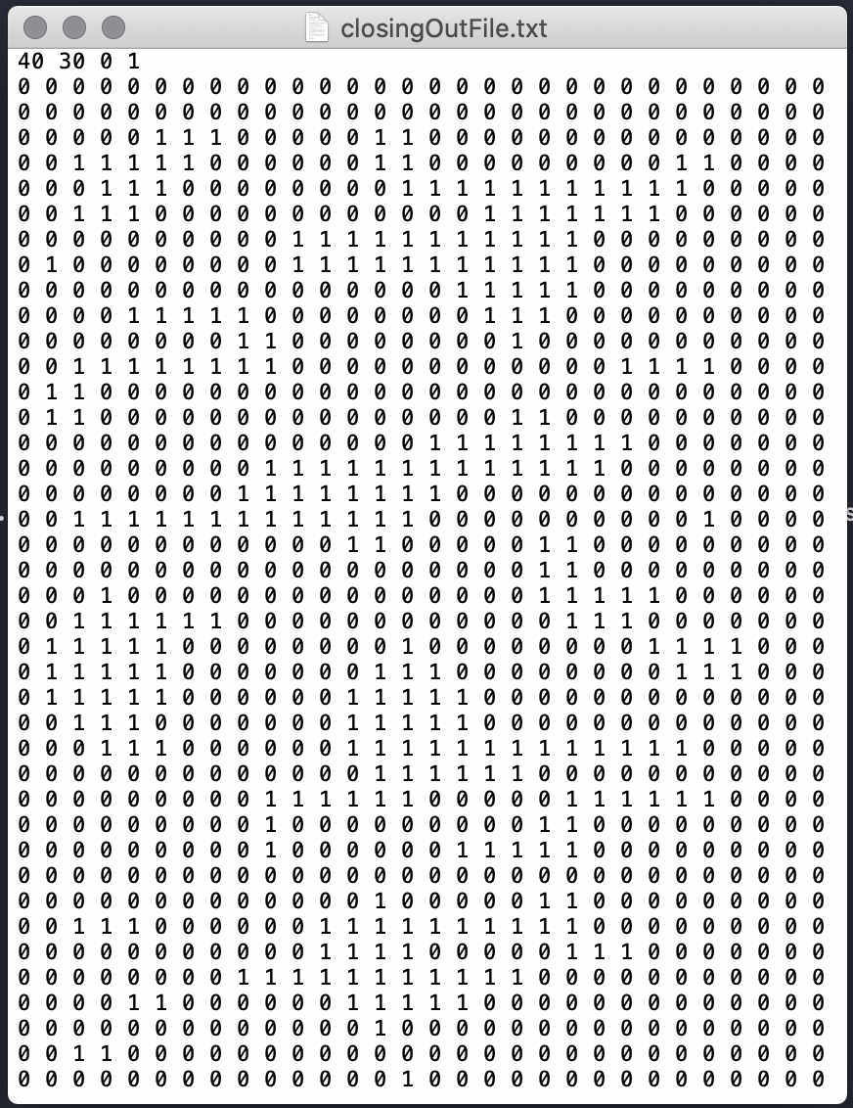

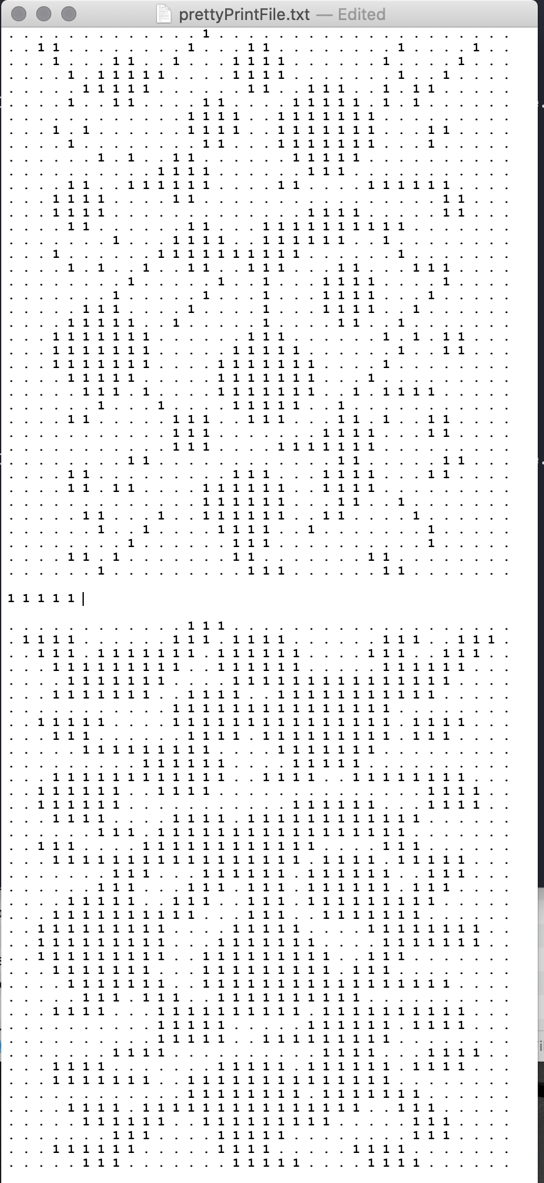

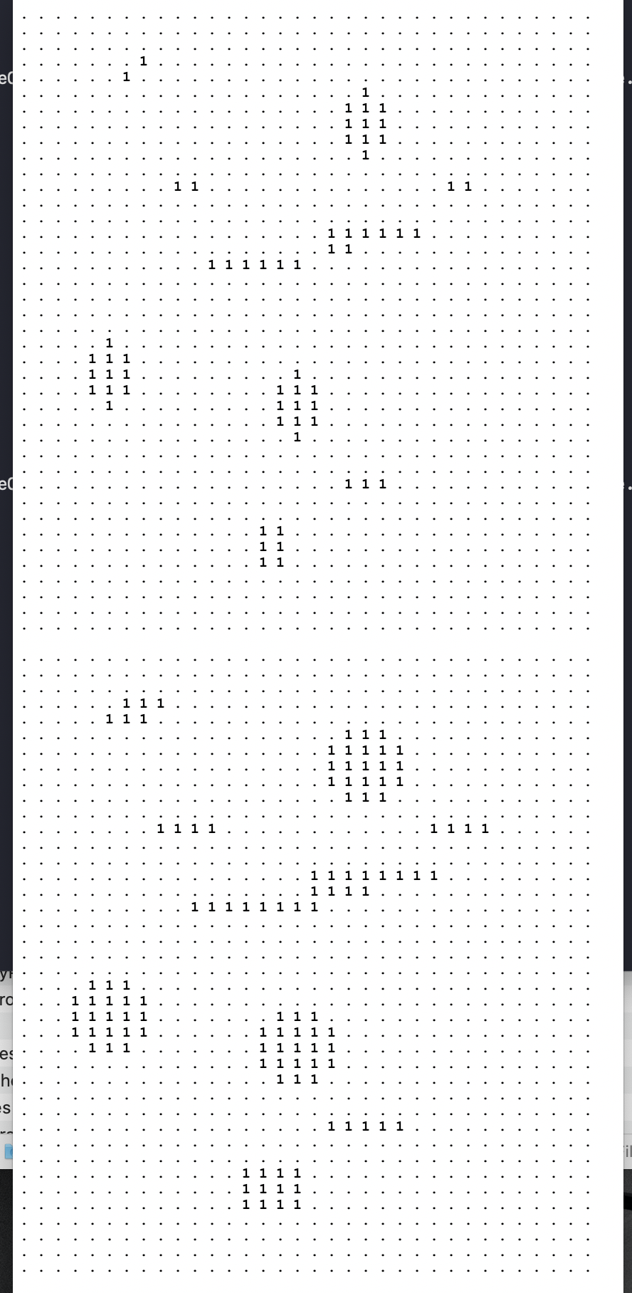

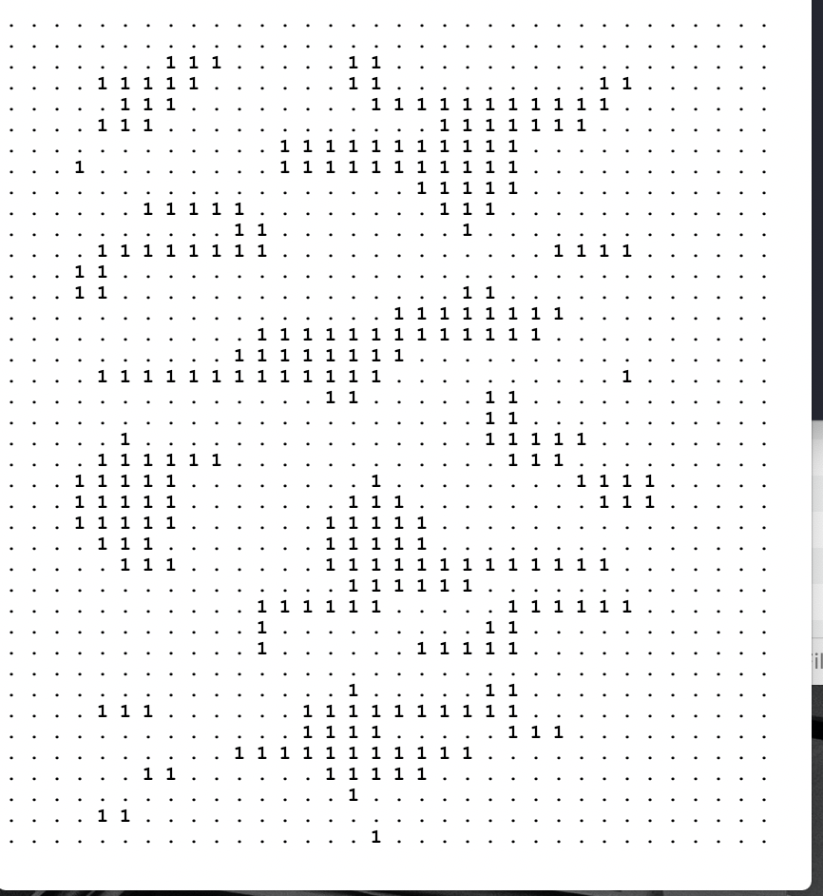

**END OF TEST 1**

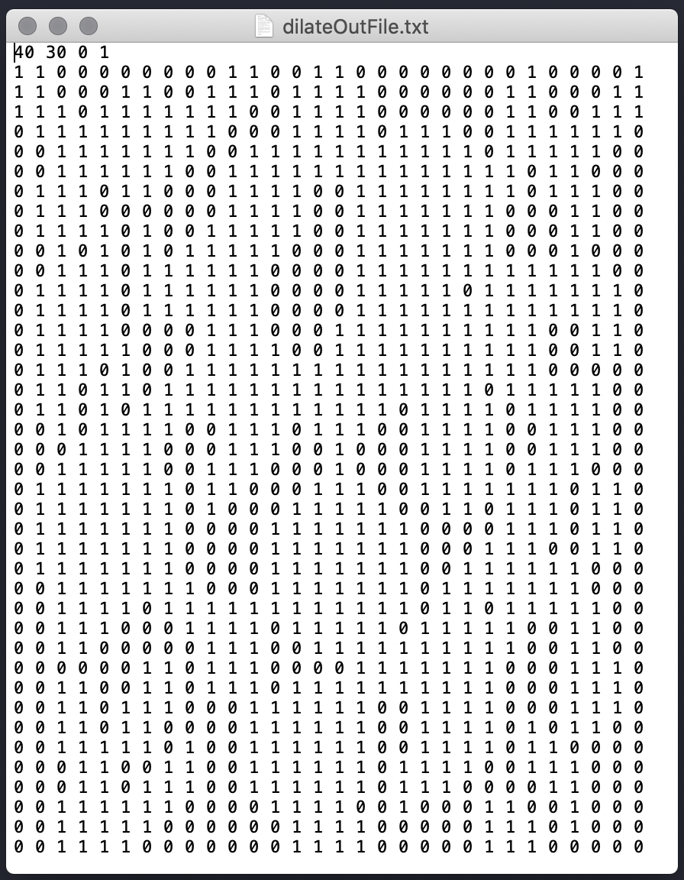**TEST 2: Img-1, Struct-4**

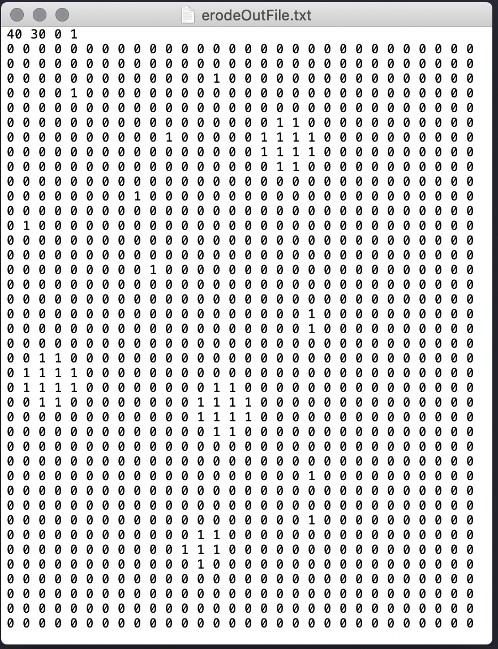

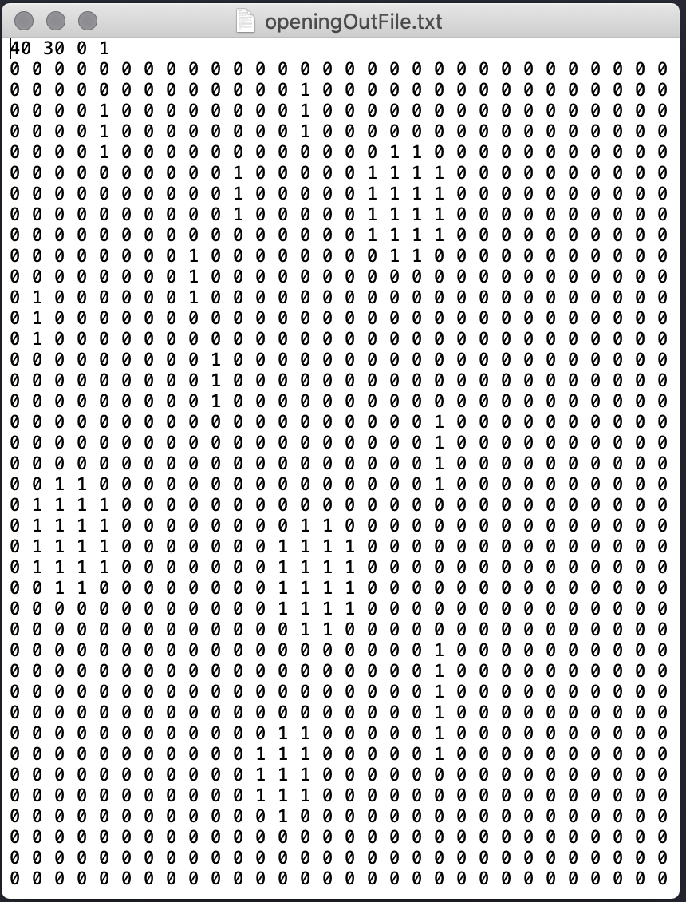

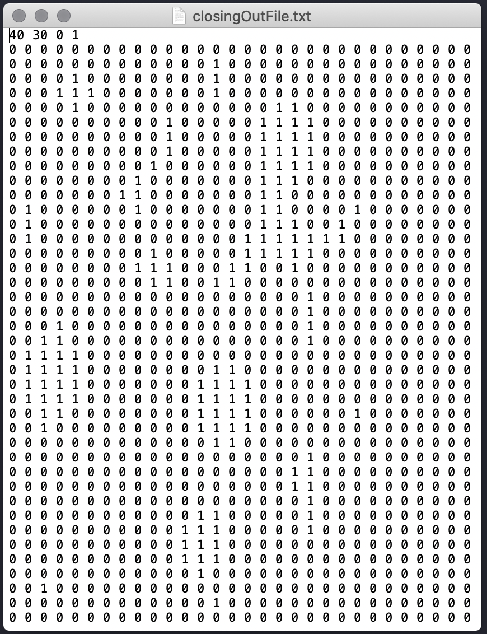**s**

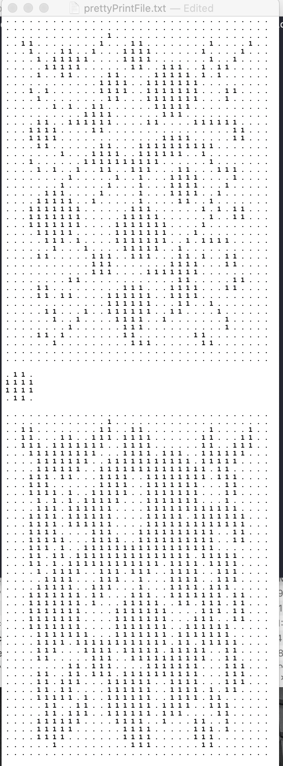

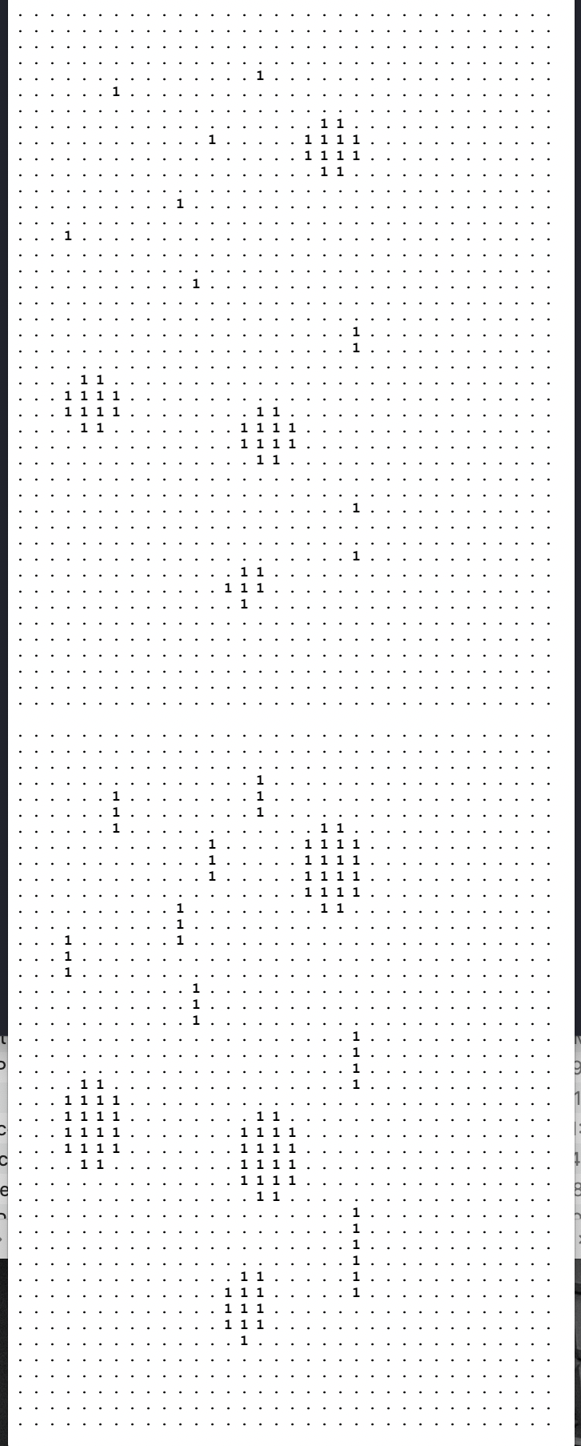

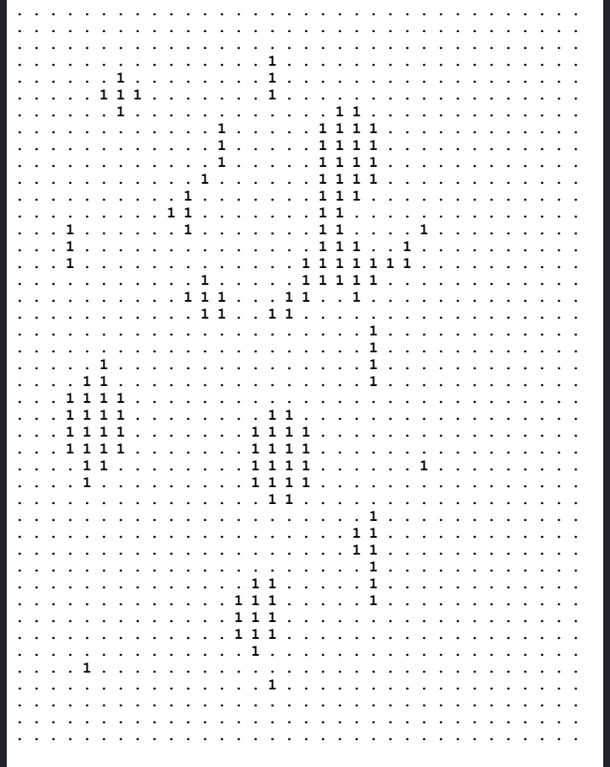

**END OF TEST 2**

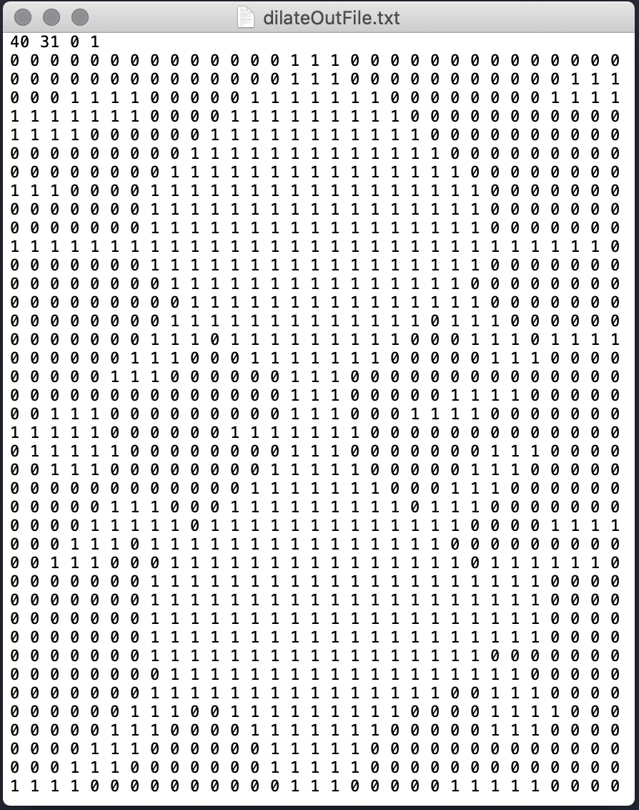**Test 3: Img-2. Struct-3**

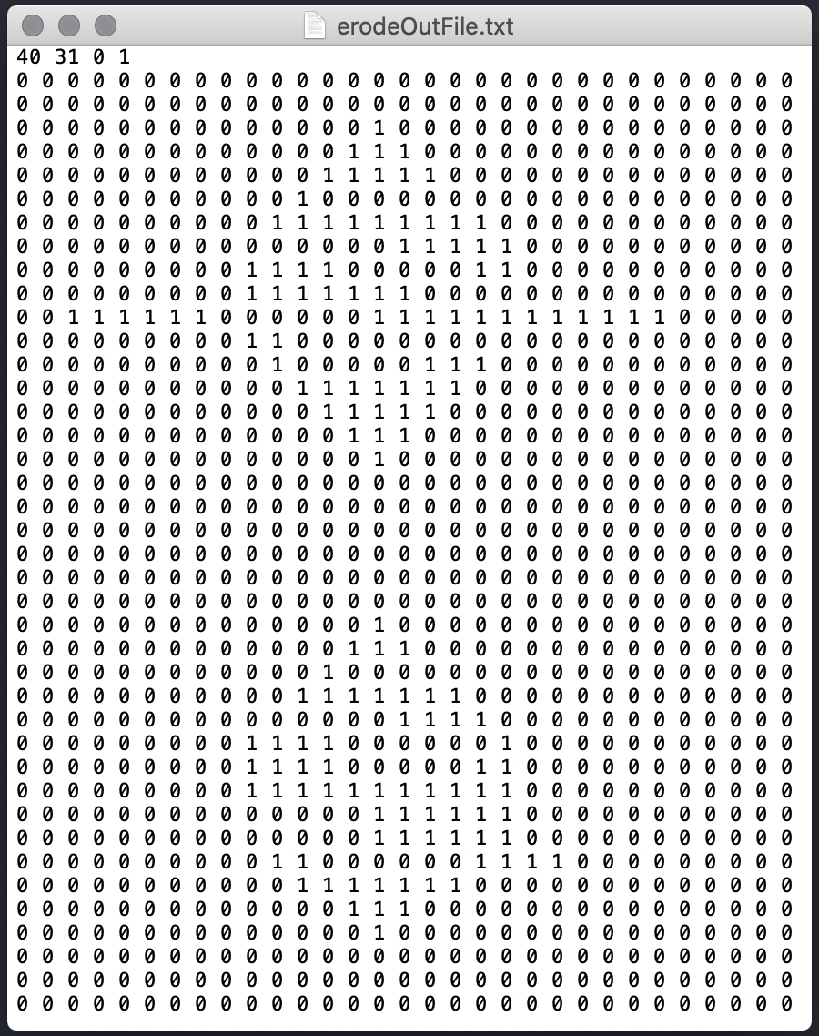

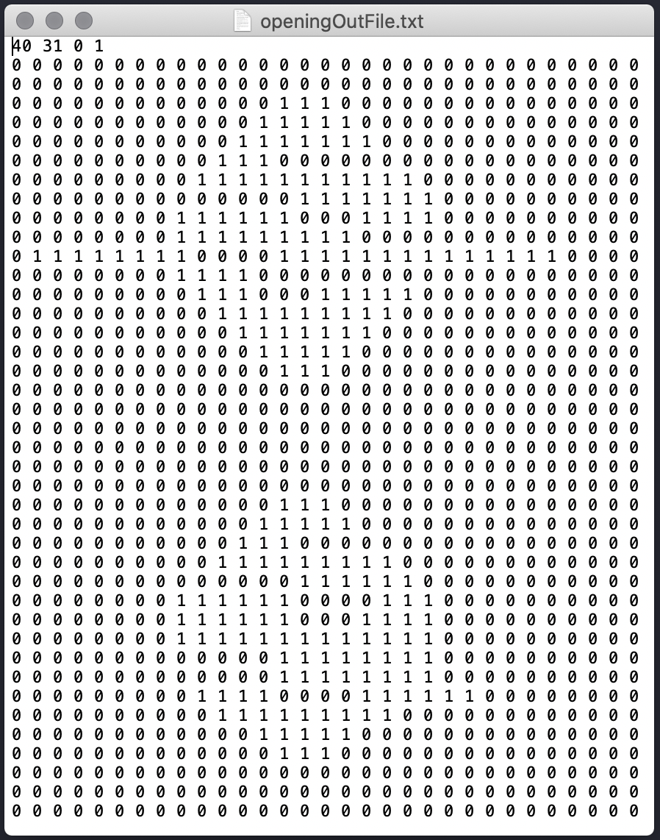

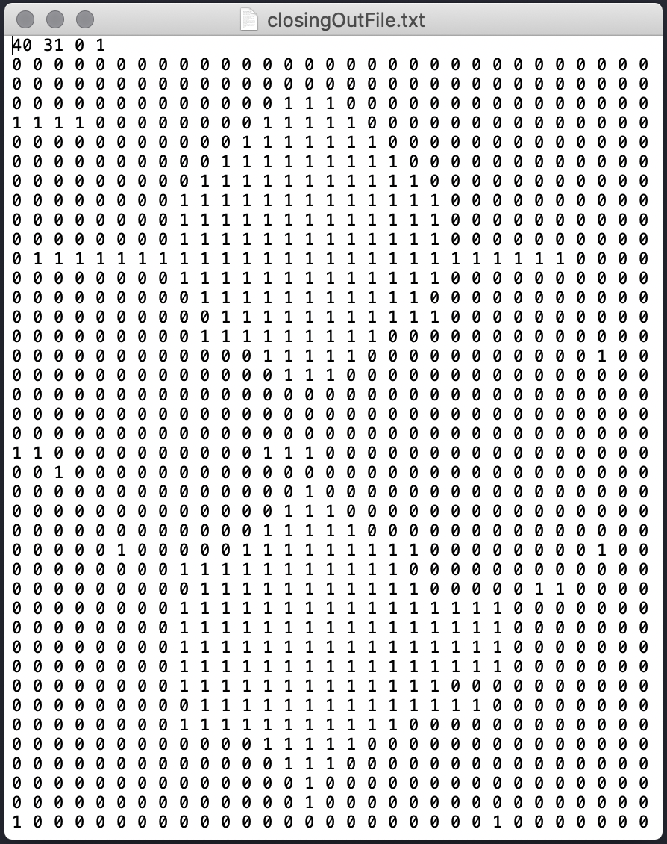

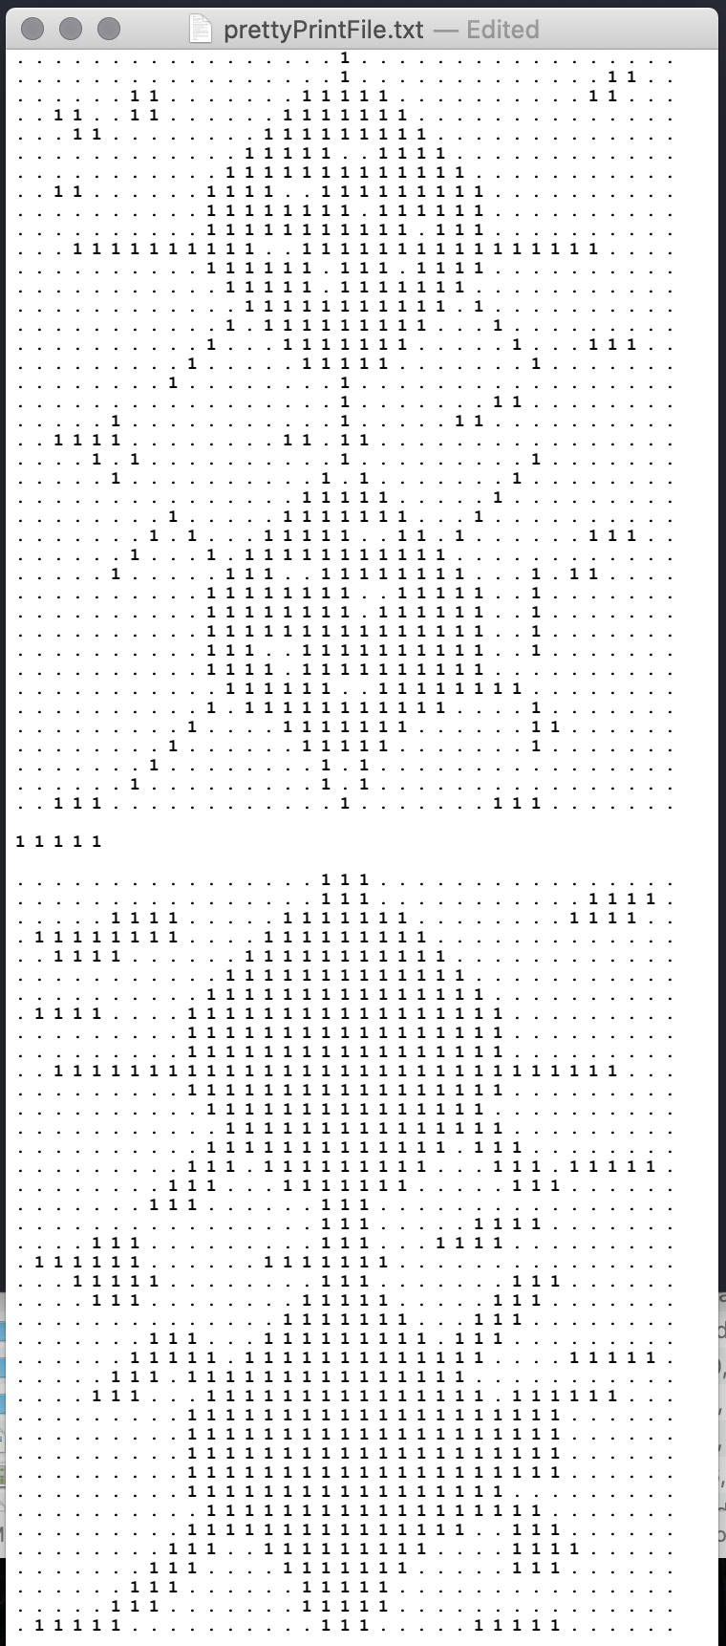

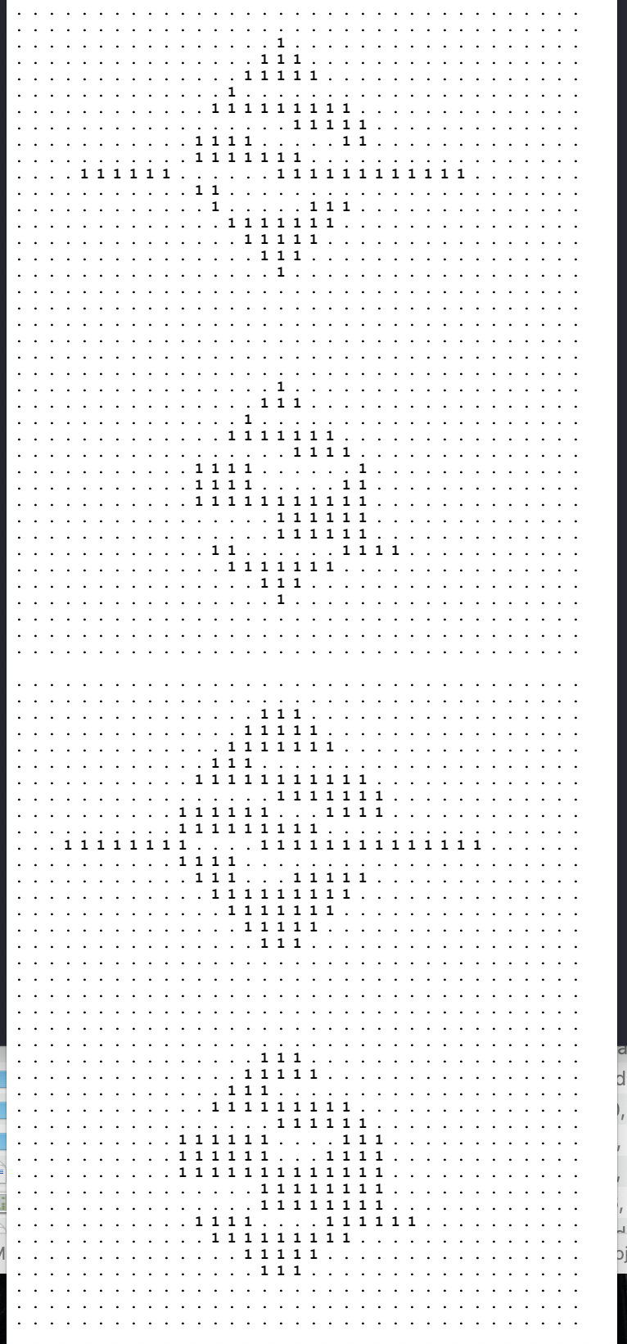

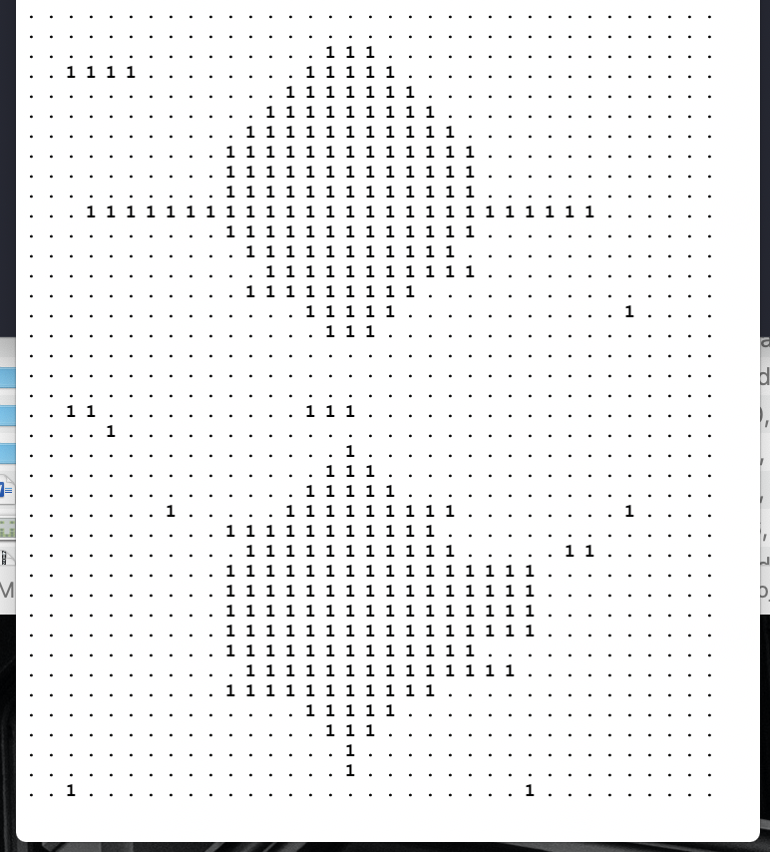

**END OF TEST 3**

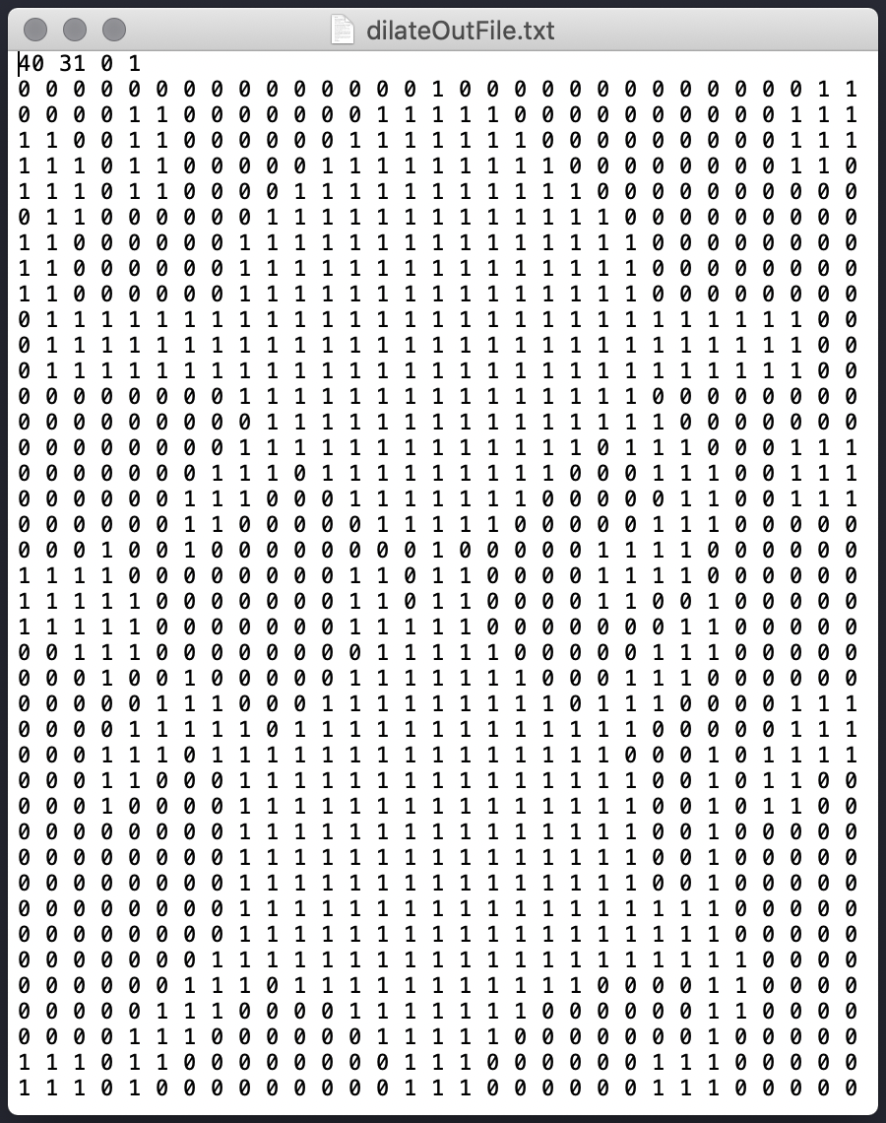**Test 4: Img-2, Img-4**

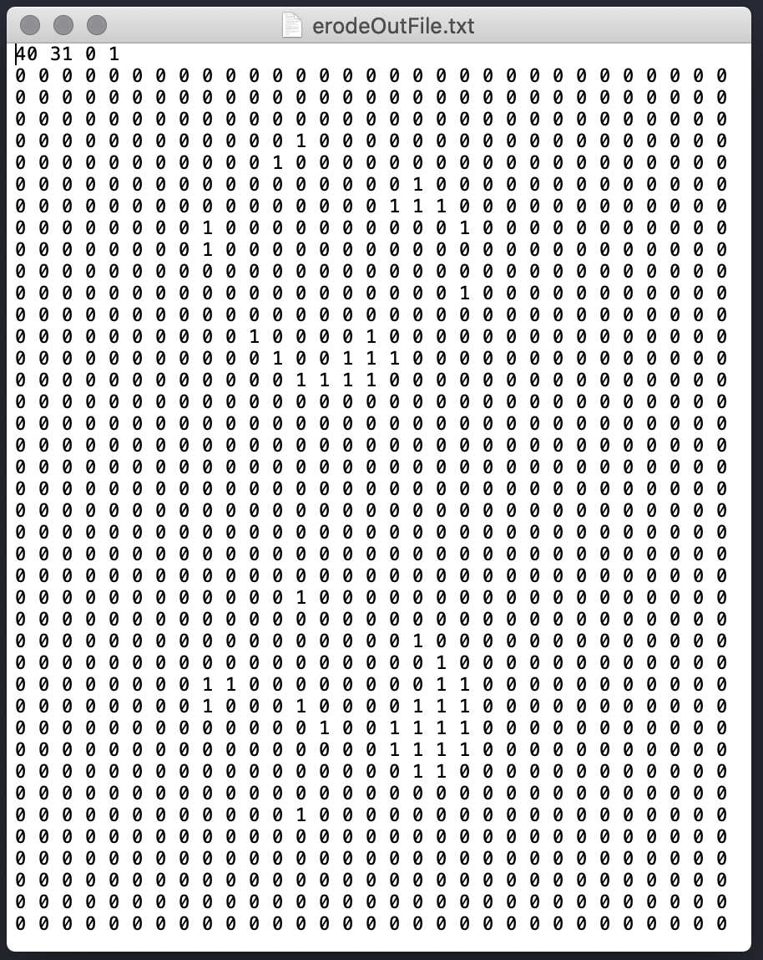

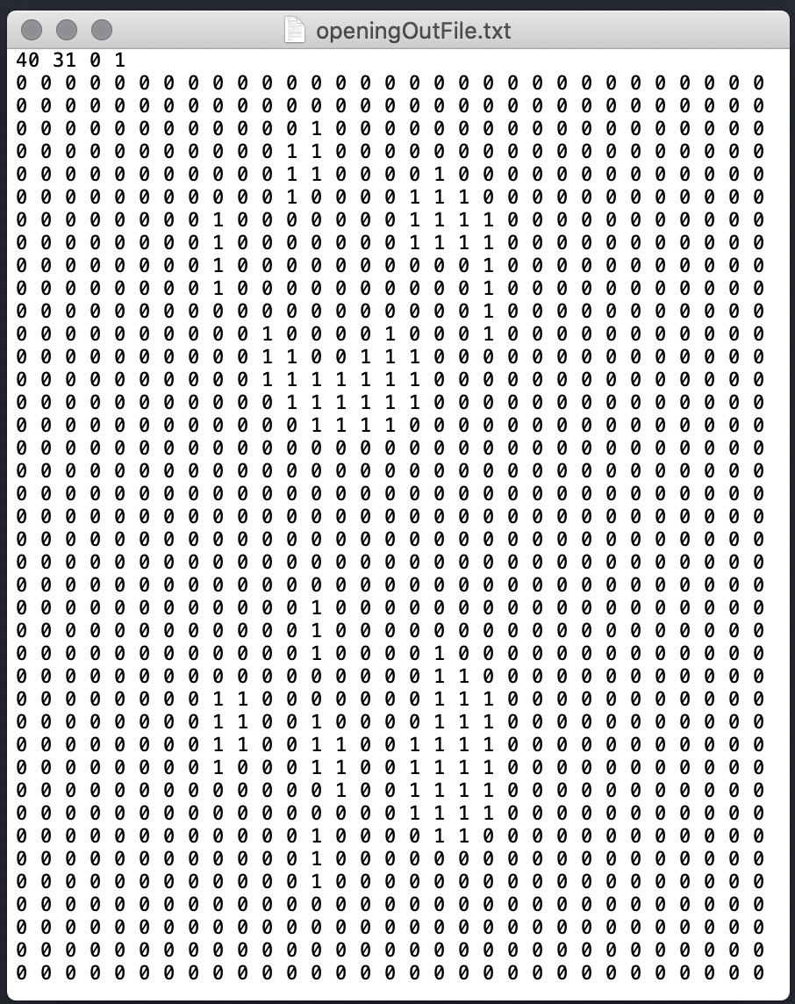

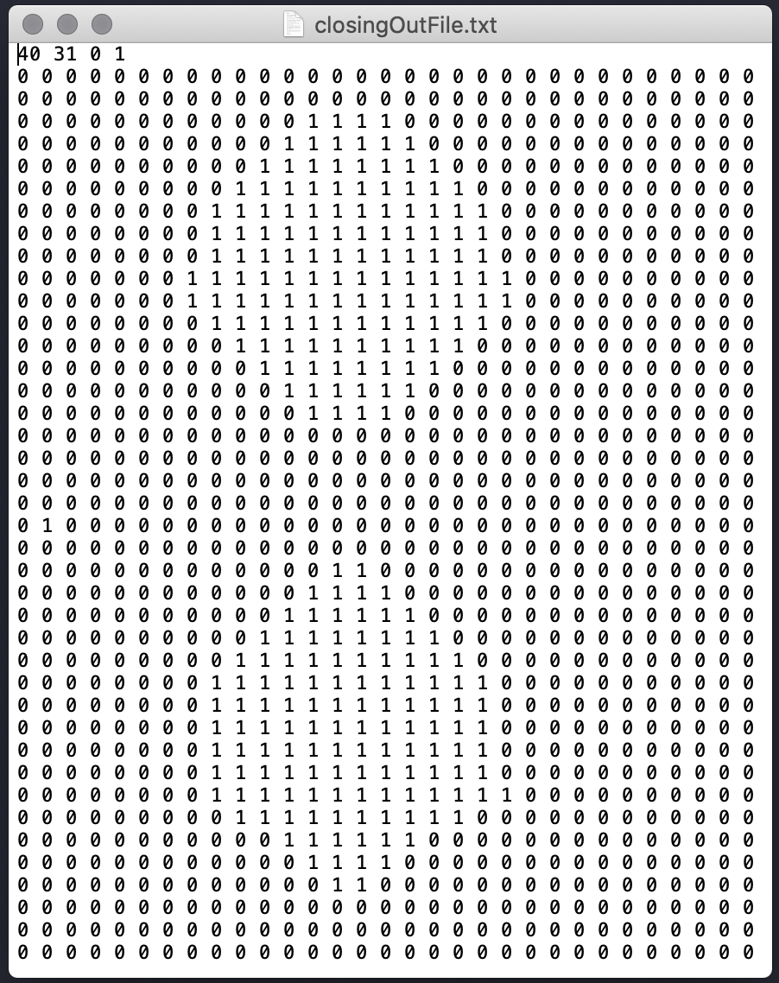

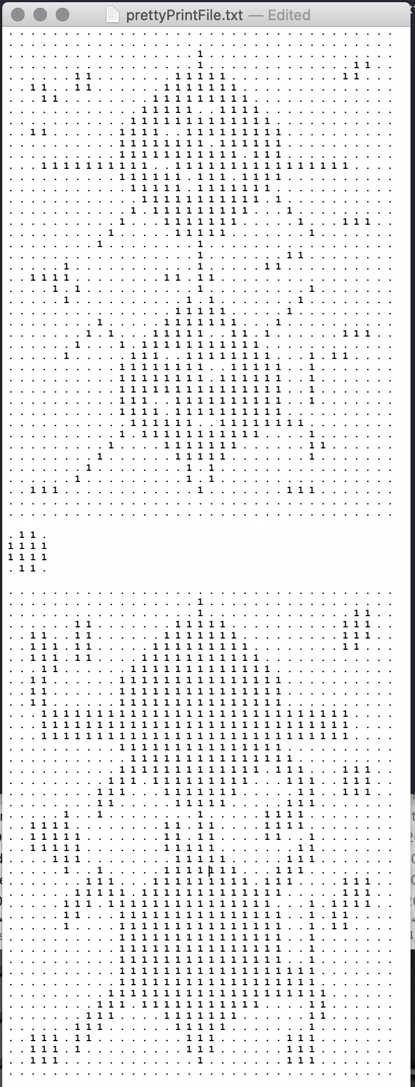

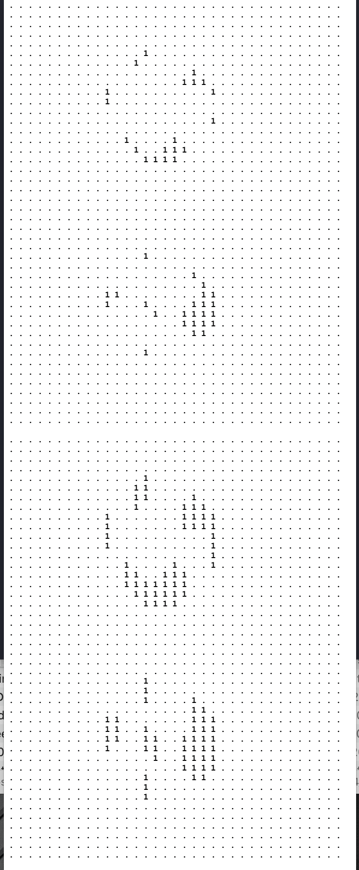

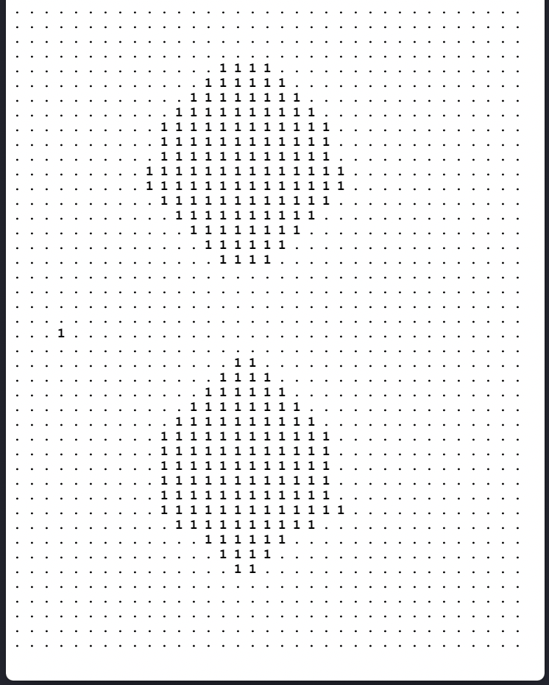

**END OF TEST 4**